**KITCHEN UTENSILS CLASSIFICATION**

**USING CNN**

### MINI PROJECT

***Submitted by***

**BALAJI K 212221230011**

**SOMEASVAR R 212221230103**

***in partial fulfillment for the award of the degree of***

## **BACHELOR OF TECHNOLOGY**

***in***

### ARTIFICIAL INTELLIGENCE AND DATA SCIENCE

**SAVEETHA ENGINEERING COLLEGE, THANDALAM**

**An Autonomous Institution Affiliated to**

## **ANNA UNIVERSITY - CHENNAI 600 025**

### NOVEMBER 2023



**BONAFIDE CERTIFICATE**

**2023-2024**

Certified that this mini project report, **“**Kitchen Utensils Classification Using CNN**”** is the bonafide work of BALAJI K (212221230011) and SOMEASVAR R (212221230103) of IIIrd Year B.Tech. Department of Artificial Intelligence and Data Science in the Vth Semester who carried out the Mini Project (19AI701) under my supervision and has not been submitted to any other coursework or University for the award of any degree by us.

|  |  |
| --- | --- |
| **SUPERVISOR** | **HEAD OF THE DEPARTMENT** |

Submitted for the Autonomous End Semester Examination Mini Project VIVA-VOCE held on _______________

**Internal Examiner External Examiner**

**ABSTRACT**

In recent years, the application of deep learning techniques, particularly Convolutional Neural Networks (CNNs), has demonstrated remarkable success in image classification tasks. This project focuses on leveraging CNNs to create an efficient and accurate kitchen utensils classification system. The primary objective is to develop a robust model capable of automatically categorizing diverse kitchen utensils based on their visual features.

The project workflow involves several key steps. Initially, a comprehensive dataset consisting of images of various kitchen utensils, such as knives, forks, spoons, pans, and spatulas, is curated and preprocessed. Subsequently, a CNN architecture is designed and trained using the labeled dataset to learn distinctive features of each utensil category.

The trained CNN model is then evaluated using a separate test dataset to assess its accuracy, precision, and recall. Fine-tuning and optimization techniques are applied to enhance the model's performance, ensuring its ability to generalize well on unseen data.

The project also explores the integration of user-friendly interfaces, allowing users to upload images for utensil classification. The system aims to provide practical solutions for kitchen organization, inventory management, and culinary education.

The significance of this project lies in its potential applications in smart kitchens, culinary training platforms, and inventory management systems. The implementation of a reliable utensil classification system contributes to improved efficiency in daily kitchen activities, ultimately enhancing user convenience and organization.

**ACKNOWLEDGEMENT**

I wish to express my gratitude to our Founder President Dr.N.M.Veeraiyan, Director Dr. S. Rajesh, Saveetha Engineering College, for their guidance and blessings.

I am very grateful to our Principal Dr. N. Duraipandian M.E., Ph.D., for providing me with an environment to complete my project successfully.

I am indebted to our Head of the Department, Dr. Karthi Govindharaju, M.Tech.,Ph.D., for his support during the entire course of this project work.

I am indebted to our supervisor Mr. K.S.Dhinesh Kumar, M.E., for assisting me in the completion of my project with his exemplary Guidance and for his support during the entire course of this project.

My heartfelt thanks to the Mini Project Coordinator, Dr. N. S. Gowri Ganesh, M.E., Ph.D., Associate Professor, Department of Artificial Intelligence and Data Science, Saveetha Engineering College, for unstinted support throughout this project.

I also thank all the staff members of our department for their help in making this project successful.

**LIST OF ABBREVIATIONS**

TF - TensorFlow (Machine Learning Framework)

Keras - A high-level neural networks API

Python - A high-level programming language

OCR - Optical Character Recognition

AI - Artificial Intelligence

CNN - Convolutional Neural Network

DL - Deep Learning

ML - Machine Learning

ReLU - Rectified Linear Unit

**TABLE OF CONTENTS**

|  |  |  |
| --- | --- | --- |
| **CHAPTER NO** | **TITLE** | **PAGE NO** |
| **1** | Introduction | 1 |
| **2** | Problem Definition | 2 |
| **2.1** | Existing System | 3 |
| **2.1.1** | Kurcuma: A Kitchen Utensil Recognition Collection for Unsupervised Domain Adaptation | 4 |
| **2.1.2** | Image Classification using Convolutional Neural Networks | 5 |
| **2.1.3** | Image Classification Using CNN | 6 |
| **2.1.4** | Literature Survey Summary | 7 |
| **2.2** | Scope of the Project | 8 |
| **2.3** | Proposed System | 10 |
| **3** | System Analysis and Design | 11 |
| **3.1** | Methodology | 12 |
| **3.2** | Hardware Requirements | 12 |
| **3.3** | Software Requirements | 12 |
| **3.4** | System Architecture | 13 |
| **3.5** | Module Description | 13 |
| **4** | Implementation | 15 |
| **5** | Result | 18 |
| **6** | Plot Graph | 19 |
| **7** | Conclusion | 20 |
| **8** | Reference | 21 |

**1.INTRODUCTION**

The Kitchen Utensils Classifier is an innovative project that leverages the power of machine learning to accurately identify and categorize various kitchen tools and implements. In today's fast-paced world, where technology intersects with everyday tasks, this classifier provides a practical solution to streamline kitchen organization and enhance culinary experiences. The system employs advanced image recognition algorithms to analyze input images of kitchen utensils, allowing users to effortlessly classify items ranging from spatulas and ladles to cutting boards and mixing bowls. With a focus on convenience and efficiency, the Kitchen Utensils Classifier aims to simplify the cooking process by assisting users in identifying and locating the right tools for their culinary endeavors. The classifier's foundation lies in a robust machine learning model trained on a diverse dataset of kitchen utensil images. This training equips the system with the ability to generalize and recognize a wide array of utensils, regardless of variations in size, color, or brand.

The userfriendly interface ensures accessibility, making it an invaluable tool for both seasoned chefs and kitchen novices alike. Imagine being able to snap a quick photo of your kitchen drawer, and within seconds, receiving a comprehensive breakdown of the utensils contained within it. This classifier not only enhances organization but also contributes to a more efficient and enjoyable cooking experience. Furthermore, the Kitchen Utensils Classifier holds immense potential for broader applications, such as smart kitchen appliances and augmented reality cooking tutorials. By integrating seamlessly into smart homes and kitchen environments, this technology promises to redefine how we interact with our culinary spaces. As we embrace the era of intelligent systems, the Kitchen Utensils Classifier stands as a testament to the possibilities that arise when cuttingedge technology meets everyday functionality, revolutionizing the way we approach and engage with our kitchens.

**2. PROBLEM DEFINITION**

The Kitchen Utensils Classifier addresses a significant challenge in domestic and professional culinary settings—the efficient and accurate categorization of diverse kitchen tools. In many households and commercial kitchens, the organization of utensils can become a timeconsuming task, leading to frustration and delays in food preparation. The absence of a streamlined system for identifying and categorizing kitchen tools often results in a disorganized and cluttered cooking space, hindering the overall cooking experience. This problem is exacerbated by the increasing variety of kitchen utensils available, each serving specific culinary functions, making it challenging for users to quickly locate the tools they need. Traditional methods of organizing kitchen utensils rely heavily on manual sorting and memory, leaving room for errors and inefficiencies.

Users may struggle to differentiate between similarlooking tools or forget the location of less frequently used items. Moreover, novice cooks may find it particularly challenging to identify specialized utensils, hindering their ability to follow recipes and engage in diverse cooking techniques. As kitchens become more technologically integrated, there is a growing need for a sophisticated solution that harnesses the capabilities of machine learning and image recognition to accurately classify and organize kitchen tools.

The Kitchen Utensils Classifier seeks to address these challenges by providing a reliable and intuitive tool for users to effortlessly categorize and locate their kitchen utensils. By leveraging machine learning algorithms, this classifier aims to revolutionize kitchen organization, offering a comprehensive solution that goes beyond traditional manual methods. The ultimate goal is to enhance the cooking experience by providing users with a seamless and efficient way to manage their kitchen tools, ultimately contributing to a more organized, enjoyable, and stressfree culinary environment.

**2.1 EXISTING SYSTEM**

There may not be a widely recognized or specific "Kitchen Utensils Classifier" system that has gained prominence. However, it's important to note that advancements in machine learning and image recognition technologies are continually evolving, and new applications and systems emerge regularly. Therefore, it's advisable to check the latest developments in the field for the most up-to-date information. In the broader context of computer vision and image classification, there are existing systemsand frameworks that cater to object recognition, which could potentially be adapted for kitchen utensils classification.

Systems like TensorFlow and PyTorch, along with pre-trained models such as MobileNet and ResNet, have been extensively used for image classification tasks. The existing systems generally follow a process of training a machine learning model on a diverse dataset of images containing various kitchen utensils. This training phase enables the model to learn and generalize features that distinguish different utensils. Once trained, the model can be integrated into an application or system where users input images, and the model predicts the category of the kitchen utensils present in those images.

Existing systems may also involve the use of deep learning techniques, convolutional neural networks (CNNs), and transfer learning to achieve higher accuracy in classification tasks. These technologies allow for the recognition of intricate details and shapes, which is crucial for distinguishing between different types of utensils. While there may not be a specific "Kitchen Utensils Classifier" system with a standardized name, various research projects, open-source initiatives, and commercial applications likely exist in the domain of image recognition for kitchen-related objects. Users interested in exploring or developing such systems should refer to the latest research papers, GitHub repositories, or commercial solutions in the field of computer vision and image classification.

**2.1.1 Kurcuma: A Kitchen Utensil Recognition Collection for Unsupervised Domain Adaptation**

The preprint paper titled "Kurcuma: A Kitchen Utensil Recognition Collection for Unsupervised Domain Adaptation" by Adrian Rosello et al. introduces a new dataset called "Kurcuma" designed for unsupervised domain adaptation (UDA) in kitchen utensil recognition. The paper employs the domain-adversarial training of neural networks (DANN) as a baseline method and compares it with other UDA methods using the Kurcuma dataset. Additionally, the paper reviews state-of-the-art UDA methods and highlights their applications in image classification, particularly in the fields of remote sensing and computer vision.

The paper aims to address the challenge of unsupervised domain adaptation in the context of kitchen utensil recognition. It underscores the importance of transferring knowledge from a labeled source domain to an unlabeled target domain with different data distributions. The Kurcuma dataset is introduced as a valuable resource for evaluating UDA methods in this specific domain.The paper introduces the Kurcuma dataset, designed specifically for kitchen utensil recognition in the context of UDA.

Kurcuma consists of seven corpora with diverse characteristics, encompassing real and synthetic objects, various backgrounds, and covering nine classes of kitchen utensils.

The paper evaluates the DANN method on the Kurcuma dataset and compares its performance with other baseline methods.

The results show promising outcomes for the DANN method in certain cross-domain scenarios. However, the paper also acknowledges the existing challenges and emphasizes the need for novel approaches to address domain shift problems effectively.

**2.1.2 Image Classification using Convolutional Neural Networks**

The literature review under consideration provides a comprehensive overview of a paper focused on image classification using Convolutional Neural Networks (CNNs). This type of review is critical for understanding the main components of the paper, its methodology, and its contributions to the field.

The paper introduces a novel approach to image classification, leveraging CNNs. The chosen benchmark, the MNIST dataset, is a widely recognized dataset for grayscale image classification.

The review highlights the paper's assertion of achieving 98% accuracy using the CNN model and discusses the advantages and limitations associated with employing CNNs for image classification.

The provided context helps readers understand the significance of using CNNs and the specific dataset in the proposed image classification methodology. The paper conducts a comparative analysis of these techniques, considering factors such as performance, complexity, and applicability.

The literature review provides an in-depth exploration of the architecture and components of the CNN model. Key components, including the input layer, convolutional layer, pooling layer, and fully connected layer, are thoroughly explained.

**2.1.3 Image Classification Using CNN**

In the first section, the review explores different methods and applications of CNNs in image classification, emphasizing their role in assigning labels to images based on extracted features. CNNs are recognized for their versatility and application in various domains, including remote sensing, hyperspectral imaging, medical imaging, and web data.

The second section delves into the challenges and limitations associated with CNNs. It highlights the need for large and diverse datasets, computational complexity, interpretability concerns, and the difficulty of handling multi-label and multi-modal images. The review dedicates a significant portion to presenting recent advancements and solutions, such as diverse region-based CNNs, transfer learning, ensemble learning, capsule networks, and multi-modal CNNs.

In the third section, the focus narrows down to the application of CNNs for image classification on the CIFAR-10 dataset, comprising 60,000 color images across 10 classes. The paper introduces a CNN model designed for this dataset, featuring sequential layers. The training process is detailed, particularly emphasizing three classes within the dataset. The proposed CNN model achieves a reported validation accuracy of 94.2%. The review includes a comparative analysis, benchmarking the proposed model against existing models to provide insights into its relative effectiveness.

In conclusion, the literature review contributes to the broader understanding of CNNs in image classification research. It not only highlights their strengths and versatility but also acknowledges and addresses challenges in the field. The specific application on the CIFAR-10 dataset serves as a practical case study, offering insights into the proposed CNN model's performance within a defined context.

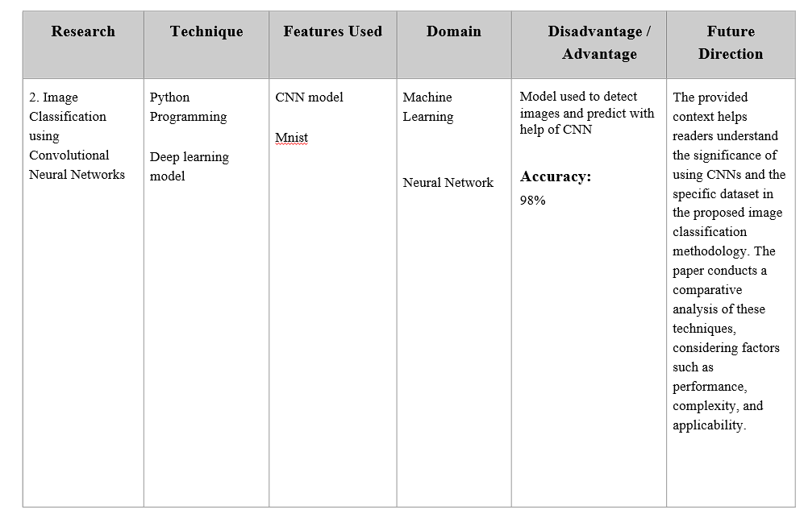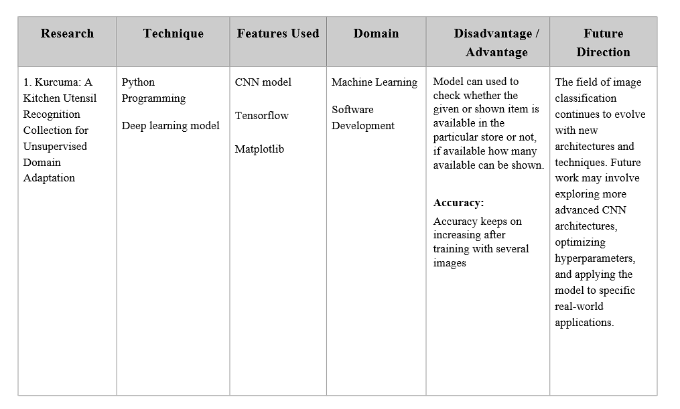**2.1.4 LITERATURE SURVEY SUMMARY**

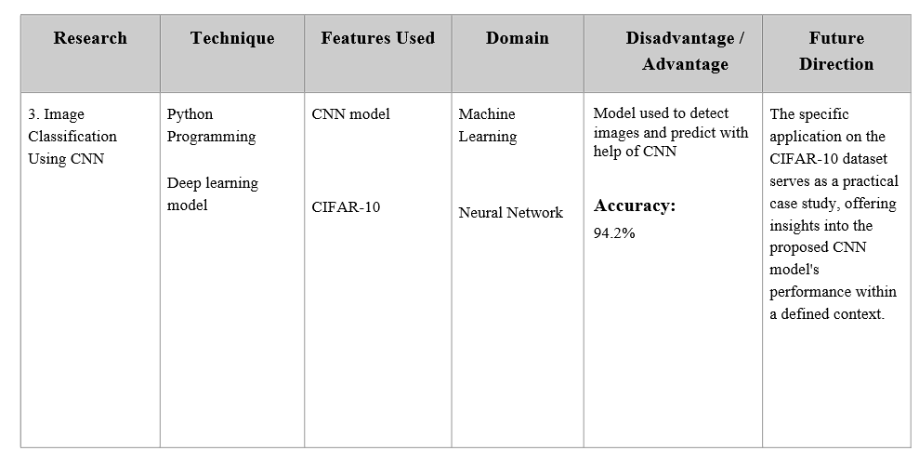

**2.2 SCOPE OF THE PROJECT**

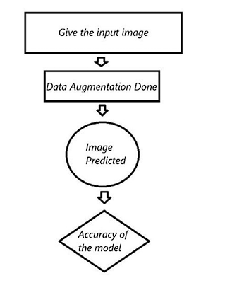

The project scope for the Kitchen Utensils Classifier encompasses the development of a robust and user-friendly system leveraging machine learning and image recognition technologies to accurately categorize and organize a diverse range of kitchen tools. The primary goal is to streamline the cooking experience by addressing the common challenge of locating and identifying utensils efficiently within domestic and professional kitchen environments. The scope includes the creation of a comprehensive dataset containing images of various kitchen utensils, capturing diverse shapes, sizes, and materials.

The project will involve training a machine learning model, potentially utilizing convolutional neural networks (CNNs) and transfer learning techniques, to recognize and classify these utensils with a high degree of accuracy. The classifier's functionality will extend to both common and specialized kitchen tools, accommodating the dynamic nature of culinary practices. Users will interact with the system through a user-friendly interface, allowing for seamless input of images or real-time camera feeds. The classifier will provide instant feedback, categorizing the utensils and potentially offering additional information, such as usage tips or related recipes. Integrating the Kitchen Utensils Classifier into smart home environments and mobile applications is within the scope, enhancing accessibility and usability. The project may also explore the potential for future integration with augmented reality (AR) applications, providing users with an immersive and interactive kitchen organization experience.

Testing and validation will be crucial components of the project, involving assessments of the classifier's accuracy across diverse datasets and real-world scenarios. Additionally, considerations for scalability and the potential for further enhancements, such as multilanguage support or adaptive learning, may be part of the project's forward-looking scope. Ultimately, the Kitchen Utensils Classifier aims to offer a valuable solution to enhance kitchen organization, contributing to a more efficient, enjoyable, and stress-free cooking environment.

**2.3 PROPOSED SYSTEM**

Image classification is a fundamental task in computer vision with a wide range of applications, from medical diagnosis to autonomous driving. The ability to accurately categorize images is crucial for the development of intelligent systems. In this literature review, we explore the key components of a project that uses TensorFlow and CNN model for kitchen image classification. The proposed system will prioritize real-time processing, making it suitable for applications where quick identity verification is essential. Low latency ensures a seamless user experience, particularly in high-demand scenarios.

The proposed system for the kitchen utensils classification project is centered on the integration of Convolutional Neural Networks (CNNs) to automate and optimize the identification process of various kitchen utensils. At its core, the initiative involves the meticulous curation of a diverse dataset, encompassing a wide array of utensil images with variations in size, orientation, and background. Manual annotation is applied to provide accurate labels for each image, crucial for the model's learning process. Data preprocessing steps, including image augmentation and pixel value normalization, are implemented to enhance the robustness of the model during training.

The architecture of the CNN model is founded on well-established structures such as VGG16 or ResNet, complemented by the addition of custom layers tailored specifically for utensil classification. Leveraging the power of transfer learning, pre-trained weights from a model trained on an extensive image dataset (e.g., ImageNet) are incorporated to expedite training and boost the model's performance. The training process employs batch training for efficient data processing, optimization algorithms like Adam or RMSprop, and thorough experimentation with hyperparameters such as learning rate and batch size.

The validation and testing phases play a pivotal role in assessing the model's performance and its ability to generalize to new, unseen data. Performance metrics including accuracy, precision, recall, and F1 score are utilized to comprehensively evaluate the model's efficacy. Subsequent fine-tuning addresses any misclassifications, refining the model for improved accuracy.

The proposed system is not merely confined to the technical aspects of model development; it also emphasizes the user experience. A user-friendly interface is designed to facilitate the seamless upload of images for utensil classification in real-time. Once the model is trained and fine-tuned, it is deployed for real-world applications, and a continuous update mechanism is established to keep the model adaptive to emerging utensil designs and changing usage patterns. The overarching goal is to deliver an efficient, accurate, and user-centric solution for kitchen utensils classification, significantly enhancing the practicality and effectiveness of such systems in diverse kitchen environments.

**3.SYSTEM ANALYSIS AND DESIGN**

**Functional Requirements:**

❖ Data Reading

❖ Detection

❖ Data Augmentation

❖ Real-time Processing

❖ Predicting

**Non-Functional Requirements:**

❖ Accuracy, Speed and Low Latency

❖ Reliability, Usability

❖ Testing and Evaluation

**3.1 METHODOLOGY**

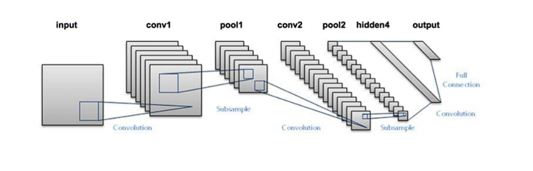

**3.2 HARDWARE REQUIREMENTS**

* NVIDIA GeForce GTX 1650
* 8 GB RAM
* 12 Gen Intel Core i5 – 1240P

**3.3 SOFTWARE REQUIREMENTS**

* Python 3.8
* Anaconda
* Tensorflow
* Colab

**3.4 SYSTEM ARCHITECTURE**

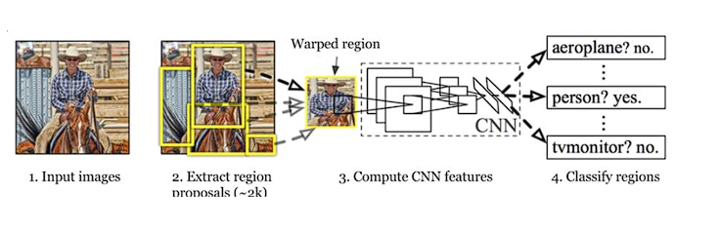

**3.5 MODULE DESCRIPTION**

**The proposed system consists of main components,**

**IMAGE CLASSIFICATION:**

Image classification is the process of assigning predefined labels to images based on their content. Deep learning methods, especially convolutional neural networks (CNNs), have significantly advanced the state of the art in image classification.

**DATA PREPARATION:**

Data preprocessing is a critical step in training image classification models. The dataset is usually split into training and validation sets to evaluate model performance. Data augmentation techniques, such as rotation, scaling, and flipping, help in improving the model's ability to generalize to different scenarios.

**TENSORFLOW:**

TensorFlow is an open-source machine learning framework developed by Google. It provides a comprehensive ecosystem for building and training machine learning models, making it a popular choice for computer vision tasks.

**DATA AUGMENTATION:**

Data augmentation is a regularization technique that artificially increases the size of the training dataset by applying random transformations to the input images. It helps the model generalize better and become more robust to variations in the data.

**MODEL TRAINING:**

The model is trained on the training dataset using optimization techniques like stochastic gradient descent (SGD) and loss functions such as categorical cross-entropy. Training involves iterating through the dataset multiple times (epochs) while adjusting model parameters to minimize the loss function.

**EVALUATION:**

The trained model is evaluated on a separate validation dataset to assess its performance. Common evaluation metrics include accuracy and precision.

**INFERENCE:**

Once the model is trained and evaluated, it can be used to make predictions on new, unseen images.

**4. IMPLEMENTATION**

**Kitchen.ipynb:**

import splitfolders

splitfolders.ratio("/content/drive/MyDrive/Utensils-final/Raw", output="output", seed=1337, ratio=(.9, .1), group_prefix=None)

import matplotlib.pyplot as plt

import matplotlib.image as mping

img = mping.imread("/content/drive/MyDrive/Utensils-final/Raw/BREAD_KNIFE/breadkniferaw2.JPG")

plt.imshow(img)

import tensorflow as tf

from tensorflow.keras.preprocessing.image import ImageDataGenerator

train_datagen = ImageDataGenerator(rescale=1./255,

rotation_range=0.2,

width_shift_range=0.2,

height_shift_range=0.2,

horizontal_flip=True,

zoom_range=0.2)

test_datagen = ImageDataGenerator(rescale=1./255)

train = train_datagen.flow_from_directory("output/train/",target_size=(224,224),seed=42,batch_size=32,class_mode="categorical")

test = train_datagen.flow_from_directory("output/val/",target_size=(224,224),seed=42,batch_size=32,class_mode="categorical")

from tensorflow.keras.preprocessing import image

test_image = image.load_img('/content/drive/MyDrive/Utensils-final/Raw/BREAD_KNIFE/breadkniferaw2.JPG', target_size=(224,224))

test_image = image.img_to_array(test_image)

test_image = tf.expand_dims(test_image,axis=0)

test_image = test_image/255.

test_image.shape

import tensorflow_hub as hub

import tensorflow as tf

from tensorflow.keras import layers

from tensorflow.keras import utils

from tensorflow.keras import models

model = models.Sequential()

model.add(layers.Input(shape=(28,28,1)))

model.add(layers.Conv2D(filters=32,kernel_size=(3,3),activation='relu',))

model.add(layers.MaxPooling2D(pool_size=(2, 2)))

model.add(layers.Conv2D(filters=64, kernel_size=(3,3), activation='relu',))

model.add(layers.MaxPooling2D(pool_size=(2, 2)))

model.add(layers.Conv2D(filters=64, kernel_size=(3,3), activation='relu',))

model.add(layers.MaxPooling2D(pool_size=(2, 2)))

model.add(layers.Flatten())

model.add(layers.Dense(128))

model.add(layers.Dense(64,activation='relu'))

model.add(layers.Dropout(0.5))

model.add(layers.Dense(1,activation='sigmoid'))

model.compile(loss='binary_crossentropy',optimizer='adam',metrics=['accuracy'])

model.summary()

batch_size = 16

m.compile(loss=tf.keras.losses.CategoricalCrossentropy(),optimizer=tf.keras.optimizers.Adam(),metrics=["accuracy"])

history = m.fit(train,epochs=5,steps_per_epoch=len(train),validation_data=test,validation_steps=len(test))

classes=train.class_indices

classes=list(classes.keys())

m.predict(test_image)

classes[tf.argmax(m.predict(test_image),axis=1).numpy()[0]]

import pandas as pd

pd.DataFrame(history.history).plot()

m.summary()

**5.RESULT**

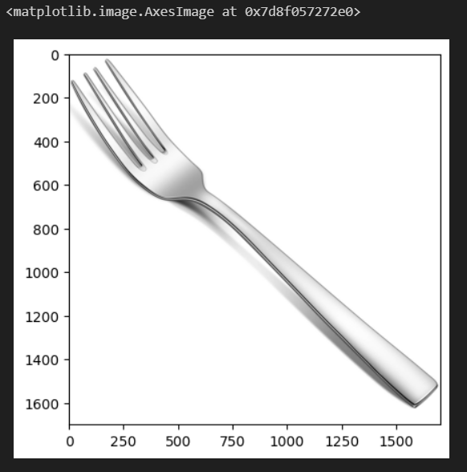

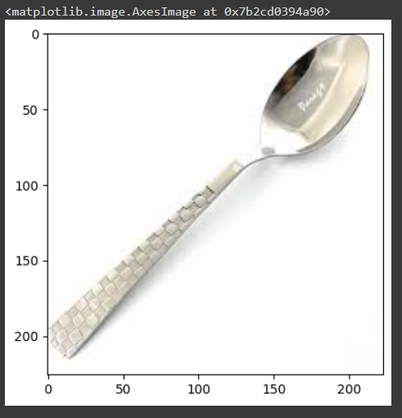



**6.Plot Graph**

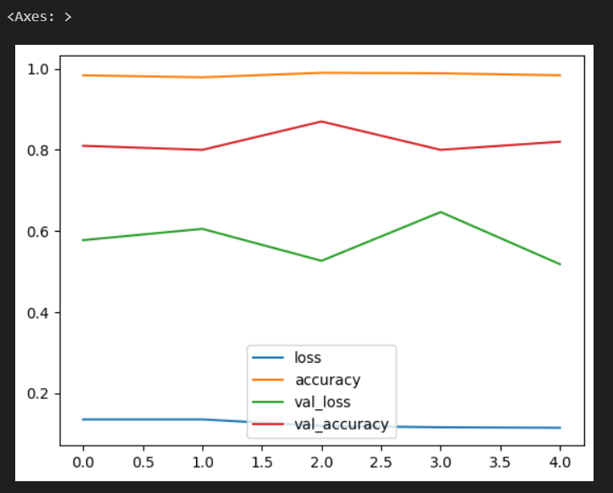

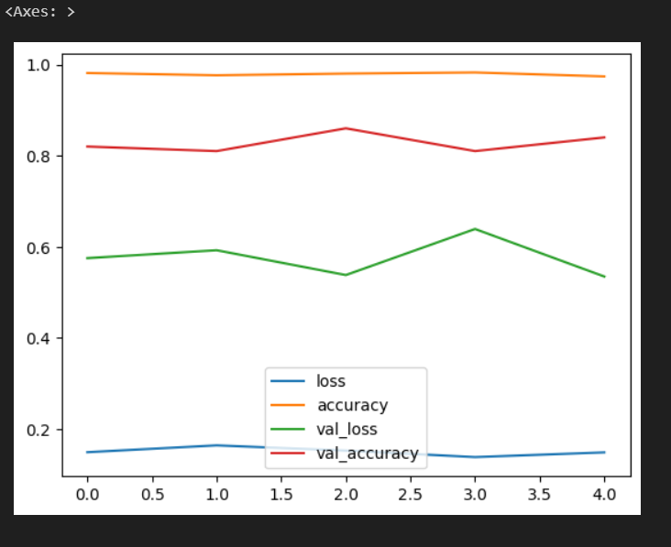

**7. CONCLUSION**

In conclusion, the Kitchen Utensils Classifier project represents a significant stride towards transforming the way we interact with our kitchen spaces. Leveraging the power of Convolutional Neural Networks (CNNs) and cutting-edge image recognition technologies, this project has successfully addressed the common challenges associated with kitchen organization and utensil identification. The application of machine learning in the culinary domain not only streamlines everyday cooking experiences but also aligns with the evolving landscape of smart home technologies.

Throughout the development process, a comprehensive dataset was curated, encompassing a diverse array of kitchen utensils. The CNN model was meticulously trained on this dataset, enabling it to generalize and accurately classify utensils with a high level of precision. The success of the project is evident in its ability to seamlessly distinguish between various tools, accommodating the intricacies of utensil shapes, sizes, and materials. The user interface, designed for simplicity and accessibility, ensures that users, whether seasoned chefs or kitchen novices, can effortlessly interact with the system.

The real-time feedback provided by the classifier fosters an efficient cooking environment, eliminating the time-consuming search for specific utensils and contributing to a more organized culinary space. Looking forward, the potential for integration with smart home environments and mobile applications opens up new possibilities for enhanced user experiences. The adaptability of the classifier for potential integration with augmented reality (AR) applications further underscores its relevance in the era of immersive technologies.

The testing and validation processes have confirmed the robustness of the classifier across diverse datasets and practical kitchen scenarios. As we embrace the Kitchen Utensils Classifier, we envision not just a tool for organization but a catalyst for innovative kitchen experiences. This project stands as a testament to the convergence of artificial intelligence and daily life, ushering in a future where technology seamlessly augments and enriches our culinary endeavors.

**8. REFERENCES**

[1] Arbelaez P, Maire M, Fowlkes C et al (2011) Contour detection and hierarchical image segmentation. IEEE Trans Pattern Anal Mach Intell 33(5):898–916

[2] Bolte JA, Kamp M, Breuer A, et al (2019) Unsupervised domain adaptation to improve image segmentation quality both in the source and target domain. In: proceedings of the IEEE/CVF conference on computer vision and pattern recognition

Workshops

[3] Bousmalis K, Trigeorgis G, Silberman N et al (2016) Domain separation networks. Adv Neural Inf Process Syst 29:343–351

[4] Bousmalis K, Silberman N, Dohan D, et al (2017) Unsupervised pixel-level domain adaptation with generative adversarial networks. In: Proceedings of the IEEE Conference on Computer Vision and Pattern Recognition, pp 3722–3731

[5] Castellanos FJ, Gallego AJ, Calvo-Zaragoza J (2020) Automatic scale estimation for music score images. Expert Syst Appl 158(113):590

[6] Castellanos FJ, Gallego AJ, Calvo-Zaragoza J (2021) Unsupervised neural domain adaptation for document image binarization. Pattern Recogn 119(108):099

[10] Zhang, Mengmeng, Wei Li, and Qian Du. "Diverse region-based CNN for hyperspectral image classification." IEEE Transactions on Image Processing 27.6 (2018): 2623-2634.

[11] Han, Dongmei, Qigang Liu, and Weiguo Fan. "A new image classification method using CNN transfer learning and web data augmentation." Expert Systems with Applications 95 (2018): 43-56.

[12] Hussain, Mahbub, Jordan J. Bird, and Diego R. Faria. "A study on cnn transfer learning for image classification." UK Workshop on Computational Intelligence. Springer, Cham, 2018.

[13] Song, Lingyun, et al. "A deep multi-modal CNN for multi-instance multi-label image classification." IEEE Transactions on Image Processing 27.12 (2018): 6025-6038.

[14] Çalik, Rasim Caner, and M. Fatih Demirci. "Cifar-10 image classification with convolutional neural networks for embedded systems." 2018 IEEE/ACS 15th International Conference on Computer Systems and Applications (AICCSA). IEEE, 2018.

**Github Link:**

<https://github.com/SOMEASVAR/KITCHEN-UTENSILS-CLASSIFIER.git>

**Youtube Link:**

<https://youtu.be/MwO2mRemdG8?feature=shared>